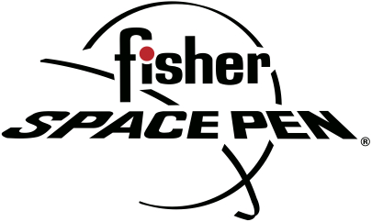

FISHER SPACE PEN
CARY FISHER, PRESIDENT
BIOGRAPHY
Cary Fisher is President and co-owner of Fisher Space Pen Co., the iconic American family business based in Boulder City, Nevada, which was founded by his father Paul C. Fisher, inventor of the original AG7 Anti-Gravity pen first used by American astronauts on Apollo 7 in 1968.
As President, Fisher oversees a company of 65 employees. Fisher graduated from Cal State Northridge with a Bachelor of Science degree in Business Administration. He was a certified public accountant at Arthur Andersen and Controller at Calbidco before joining the family business in 1996 as President and co-owner.
Fisher Space Pen is a popular favorite among consumers of all ages. It is the most advanced and dependable writing utensil, which works in freezing cold and desert heat as well as underwater, upside down and in almost any climate or situation due to its hermetically sealed cartridge, which is pressurized with nitrogen and does not rely on gravity to work. The sleek, timeless pen, which is used in the International Space Station, is also in the Museum of Modern Art in New York City, acclaimed for its elegant industrial design. Fisher Space Pen is luxury at its finest. For more information: www.spacepen.com.
Cary Fisher lives in Boulder City, Nevada with his wife Amelia, daughter Alison and sons Paul and Matt.

#####

